Respiratory System Word Sleuth
Name:________________________________________
T | R | A | C | H | E | A | A | Q | W | N | E | G | Y | X | O | I | B | K | E | Z
N | S | E | X | C | H | A | N | G | E | E | R | T | Y | U | I | I | R | J | P | E
C | A | E | R | O | B | I | C | R | E | S | P | I | R | A | T | I | O | N | P | D
O | S | S | D | D | I | F | F | U | S | I | O | N | X | D | O | W | N | S | I | I
O | A | N | A | E | R | O | B | I | C | I | I | H | C | F | D | S | C | C | G | X
L | S | D | E | L | R | T | Y | Y | U | L | H | A | V | G | H | J | H | I | L | O
E | B | R | O | N | C | H | U | S | O | K | J | L | B | N | M | K | I | E | O | I
S | N | F | D | S | A | A | W | I | W | E | L | A | C | T | I | C | O | N | T | D
D | G | E | G | H | H | J | V | B | R | E | A | T | H | I | N | G | L | C | I | N
S | T | H | R | F | G | L | H | I | E | R | G | I | S | F | G | J | U | E | S | O
A | G | H | U | G | A | G | O | U | T | W | F | O | D | F | G | H | S | K | L | B
F | G | G | H | J | Y | H | J | K | S | Y | D | N | H | U | M | A | N | T | P | R
C | A | P | I | L | L | A | R | I | E | S | D | E | C | R | E | A | S | E | S | A
D | F | G | H | J | J | K | D | I | A | P | H | R | A | G | M | Y | U | I | O | C

Glucose + Oxygen -> Carbon Dioxide + Water + Energy
The part of the body that stops food going down into your lungs

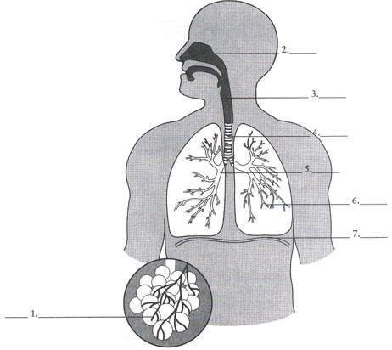
Respiration not involving oxygen
The diaphragm relaxes and moves upwards during____
During inhalation the ribs move up and _________
The acid produced during anaerobic respiration
Gas ___________ occurs between the alveoli and capillaries.
The process by which gases move between the alveoli and capillaries
The main purpose of respiration is to provide ____________ for all living cells
The volume of the lungs ______________ during exhalation
When the diaphragm contracts it moves_________
The process on inhalation and exhalation is called_______________
In the lungs _____________ diffuses into the capillaries, while _______________diffuses into the alveolus

Respiratory System Word Sleuth
Name:________________________________________
T | R | A | C | H | E | A |  |  |  | N | E | G | Y | X | O |  | B |  | E
N |  | E | X | C | H | A | N | G | E |  |  |  |  |  |  |  | R |  | P | E
 | A | E | R | O | B | I | C | R | E | S | P | I | R | A | T | I | O | N | P | D
 |  | S |  | D | I | F | F | U | S | I | O | N |  | D | O | W | N |  | I | I
 | A | N | A | E | R | O | B | I | C |  | I | H |  |  |  |  | C |  | G | X
 |  |  |  | L |  |  |  |  |  | L |  | A |  |  |  |  | H |  | L | O
E | B | R | O | N | C | H | U | S | O |  |  | L |  |  |  |  | I |  | O | I
 | N |  |  |  |  | A |  | I |  |  | L | A | C | T | I | C | O |  | T | D
 |  | E |  |  |  |  | V | B | R | E | A | T | H | I | N | G | L |  | I | N
 |  |  | R |  |  | L |  | I |  |  |  | I |  |  |  |  | U |  | S | O
 |  |  |  | G | A |  | O | U | T |  |  | O |  |  |  |  | S |  |  | B
 |  |  |  |  | Y |  |  |  |  | Y |  | N |  |  |  |  |  |  |  | R
C | A | P | I | L | L | A | R | I | E | S | D | E | C | R | E | A | S | E | S | A
 |  |  |  |  |  |  | D | I | A | P | H | R | A | G | M |  |  |  |  | C

Glucose + Oxygen -> Carbon Dioxide + Water + Energy
The part of the body that stops food going down into your lungs

Respiration not involving oxygen
The diaphragm relaxes and moves upwards during____
During inhalation the ribs move up and _________
The acid produced during anaerobic respiration
Gas ___________ occurs between the alveoli and capillaries.
The process by which gases move between the alveoli and the capillaries
The main purpose of respiration is to provide ____________ for all living cells
The volume of the lungs ______________ during exhalation
When the diaphragm contracts it moves_________
The process on inhalation and exhalation is called_______________
In the lungs _____________ diffuses into the capillaries, while _______________diffuses into the alveolus

